## Express.js – Theater

**Exam Rules:**

* You have 4 hours
* When you are ready, **delete** the ***node_modules***folder, make sure all dependencies are listed in the ***package.json*** file and submit your archived project at: [SoftUni Judge](https://judge.softuni.bg/Contests/2457/JS-Back-End-Exam-28-June)
* You are provided with **HTML & CSS** resources
* You may **add attributes** (such as **class** and **dataset**), but it is forbidden to **change** **existing** attributes (such as **class** and **id**)
* You may **change "href"** attributes on links and add/change the **method** and **action** attributes of HTML Forms.
* Use **bcrypt** for hashing the password
* Use **Express.js** as a back-end framework
* Use **MongoDB** as a database with **mongoose**
* You can use whatever **view engine** you like (Handlebars, EJS, Pug etc.…)
* The application **must start** on port **3000**
* It is **forbidden** to use **React**, **Vue**, **Angular** etc.

## Application Overview

Get familiar with the provided **HTML & CSS** and create an application for **theaters.**

## Functional Requirements

The Functionality Requirements describe the functionality that the **Application** must support.

**Guest (Not Logged In)**

The **application** should provide Guest (not logged in) users with the functionality to login, register and **view** the **Guest** Home page.

**Users (Logged In)**

The **application** should provide **Users** (logged in) with the functionality to **view all the plays which are listed**, **play details page** and **they should be able to like a play**. Plays can be **public** or **not.** Users can access **only** **public plays.**

**Database Models (10 Pts)**

The **Database** of the Tutorials application needs to support **2 entities**

### User

* Username - string (required), unique
* Password - string (required)
* **Liked Plays - a collection of** Plays

### Play

* **Title - string (required), unique**
* **Description - string (required), max length of 50 symbols,**
* **Image Url - string (required),**
* **Is Public - boolean, default - false,**
* **Created at – Date or String, required**
* **Users Liked - a collection of Users**

Implement the entities with the **correct datatypes**.

### Application Pages (70 Pts)

**Guest Pages (15 Pts)**

These are the pages and functionalities, accessible by **Guests (logged out users).**

**Home Page (Logged Out User)**

List the **top three (3) public plays ordered** by the **count** of likes in **descending** order.

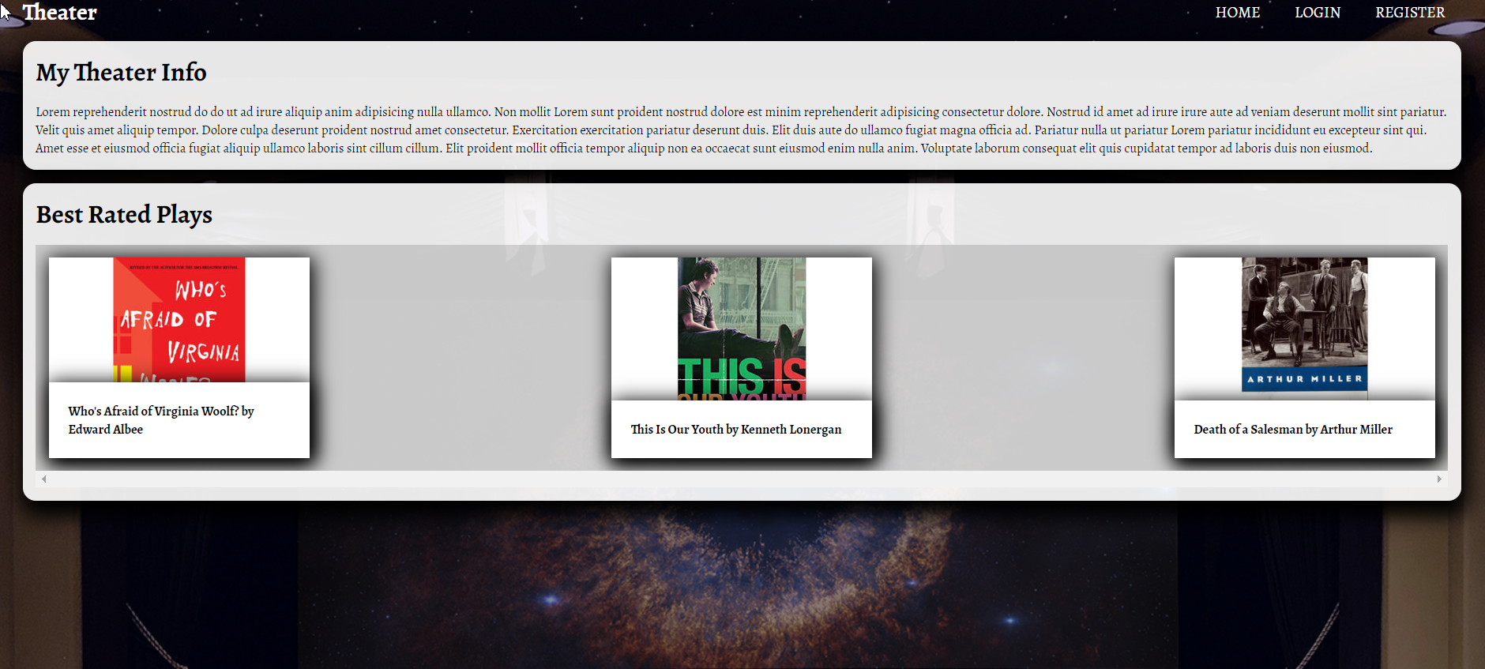

If there are no plays in the database yet, display **"No plays yet..."**

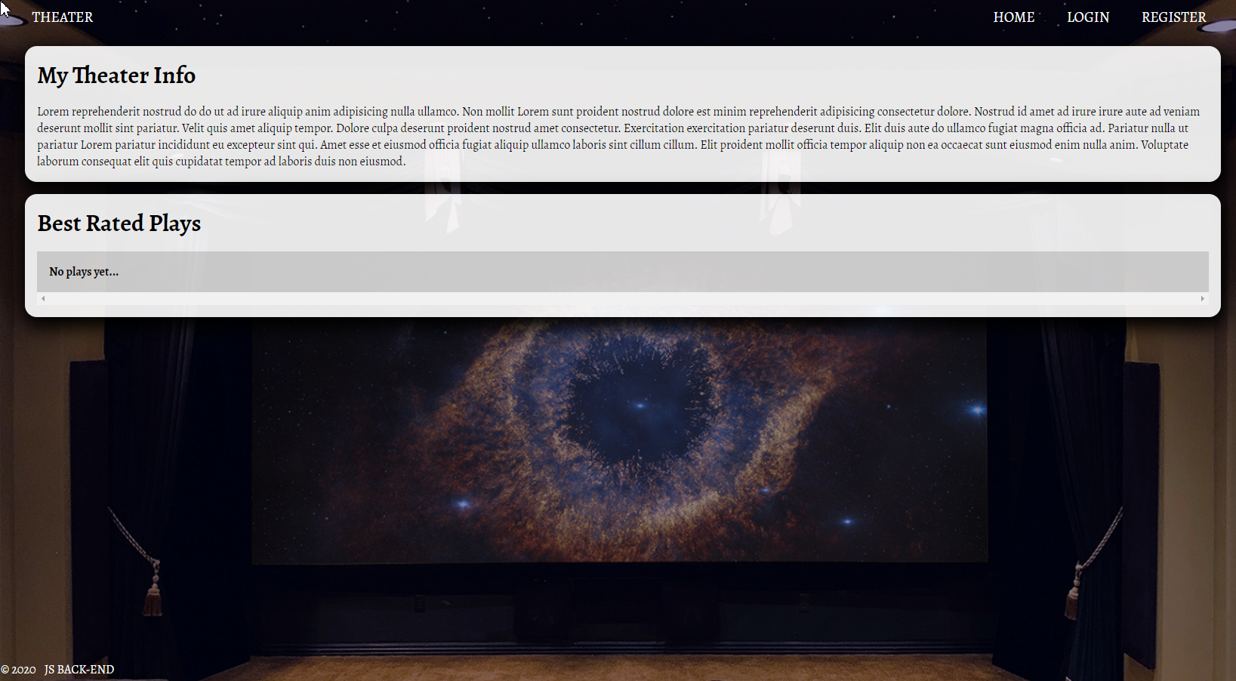

**Register Page (Logged Out User)**

Register a user inside the database with **username** and **password**. Both **passwords** must **match**!

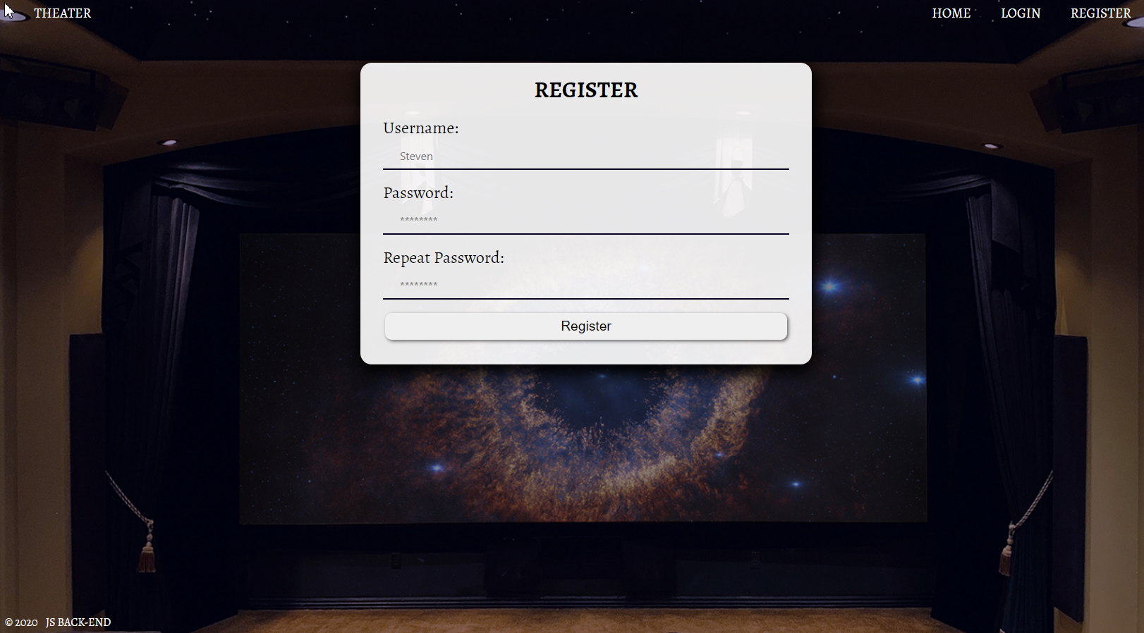

**Login Page (Logged Out User)**

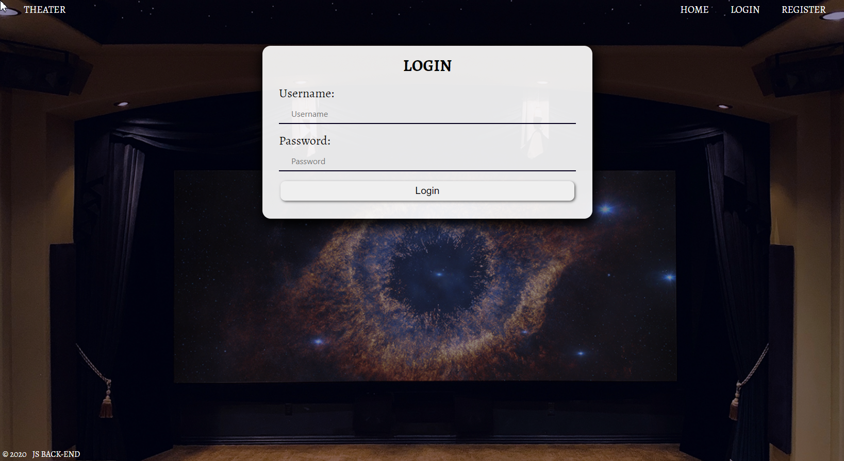

**User Pages (55 Pts)**

These are the **templates** and **functionalities**, accessible by Users (**logged in** users).

**Home Page (Logged in User)**

List **all public** plays sorted in **descending** **order** by the **created** **time** with a button **Details** which leads to a **play details page**.

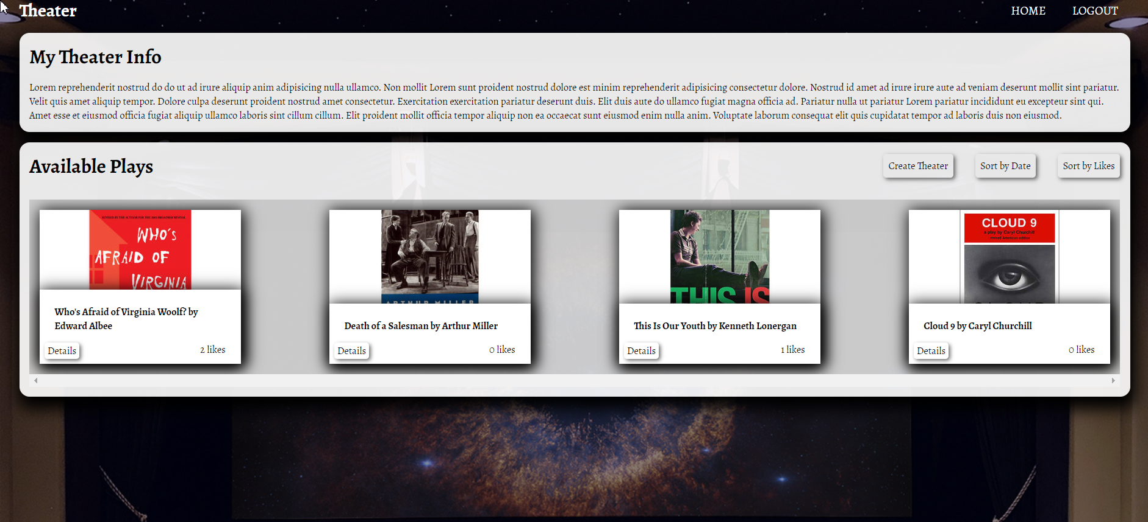

If there are no plays in the database yet, display **"No plays yet..."**

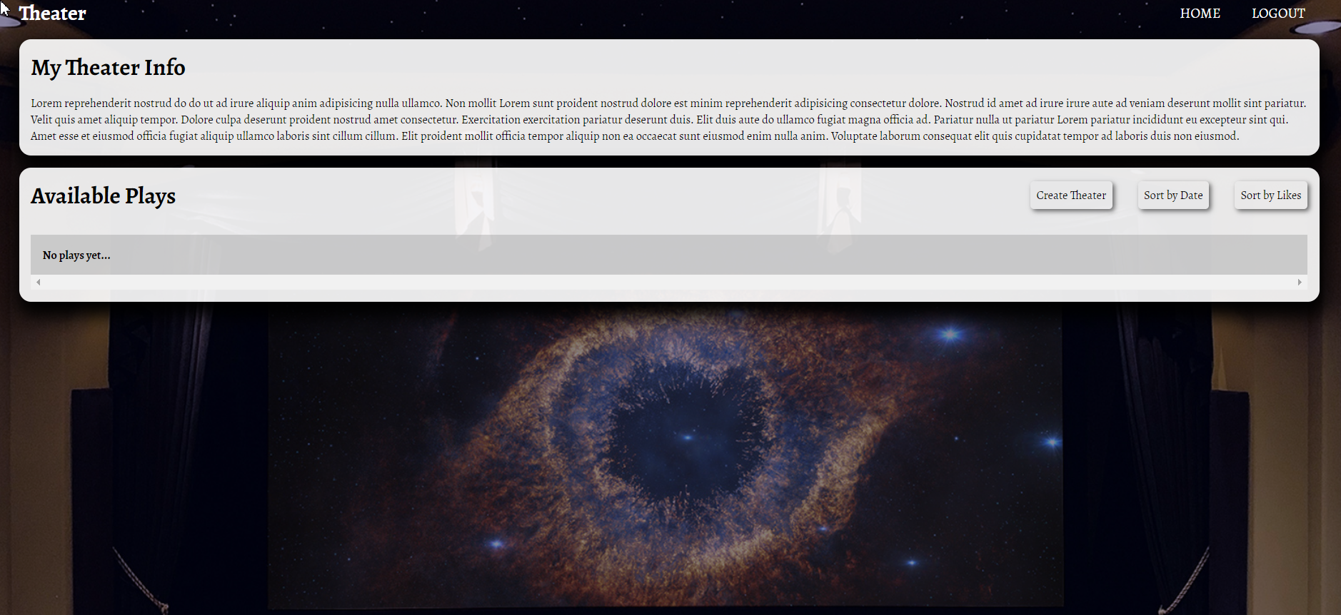

**Create Play Page (Logged in User)**

Enter play **title**, **description**, **image URL** and choose if the play will be **public** or not. You will receive the value of the checkbox as a string **"on"** if it's checked or **undefined** if it's not. You have to convert the received value as Boolean **true** or **false** and save the play in the database.

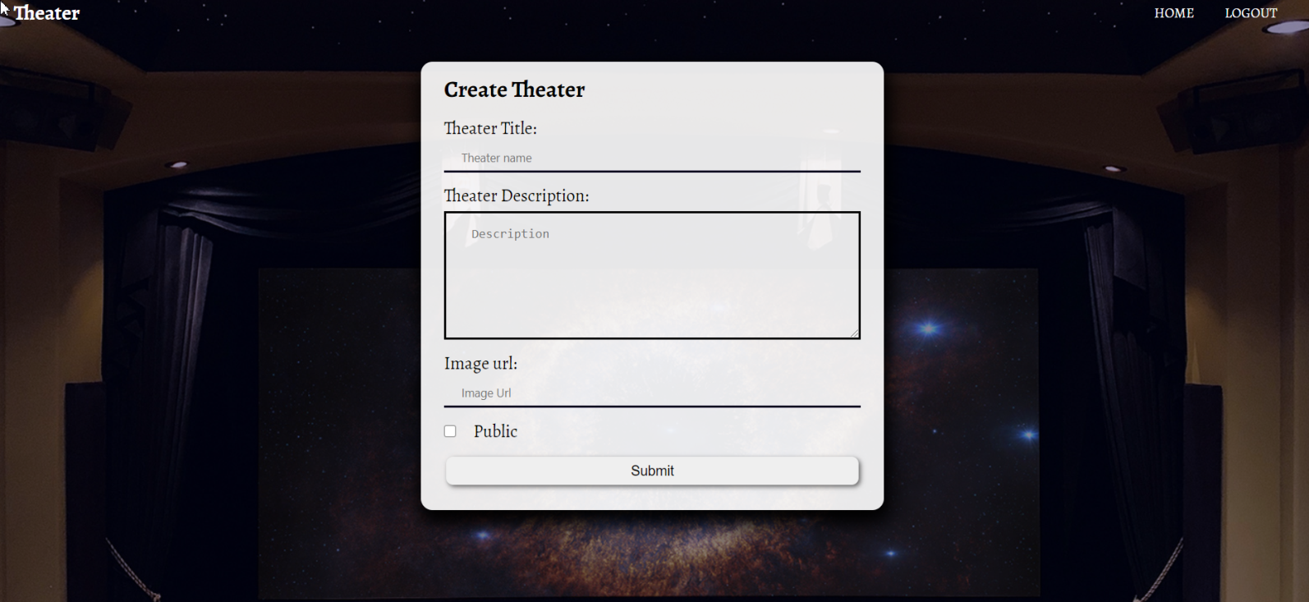

**Logged in Details Page (Logged in User)**

In the Details of a play section, you should load play **name** and **description**.

**Not Liked Play (Logged in User)**

If the user didn't like the play, you should display **Like button.**

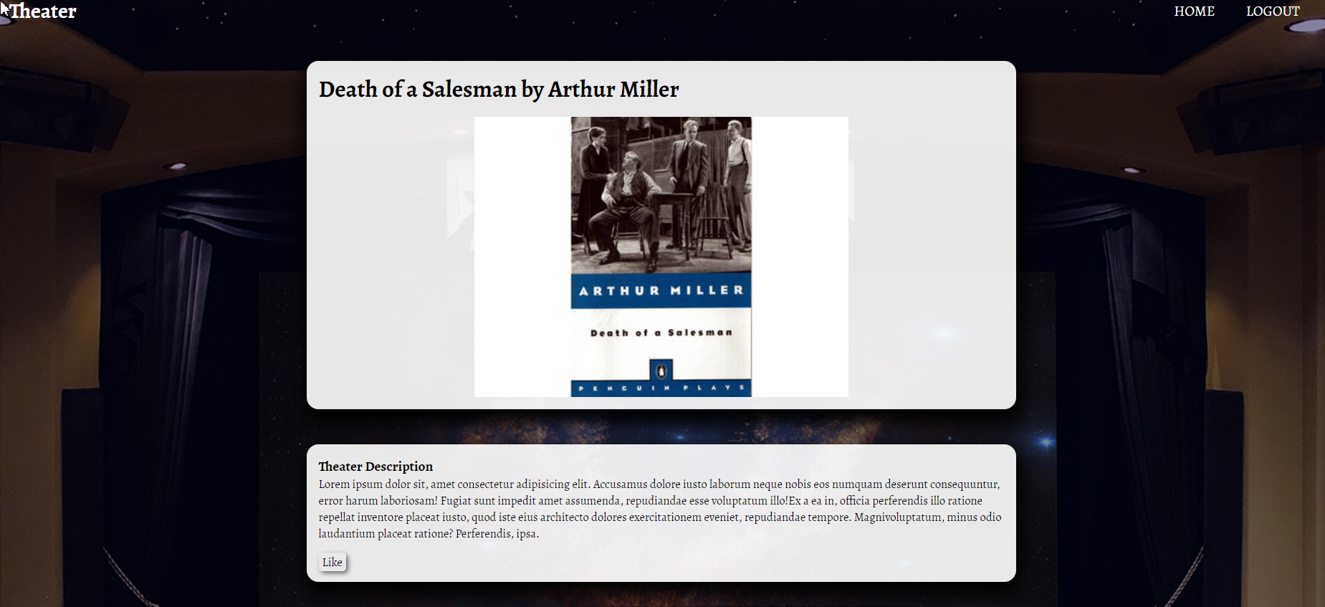

**Liked Play (Logged in User)**

**After** the user has liked the play, the **"You have already liked this play!" span element** should be **shown instead of the [Like] button.**

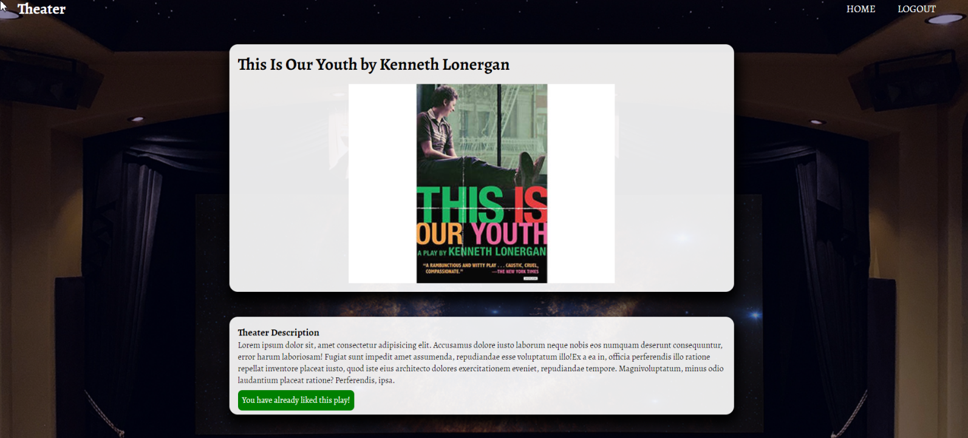

**Play Creator (Logged in User)**

The creator of the play should see **[Delete] [Edit].** The creator should NOT be able to like his plays!

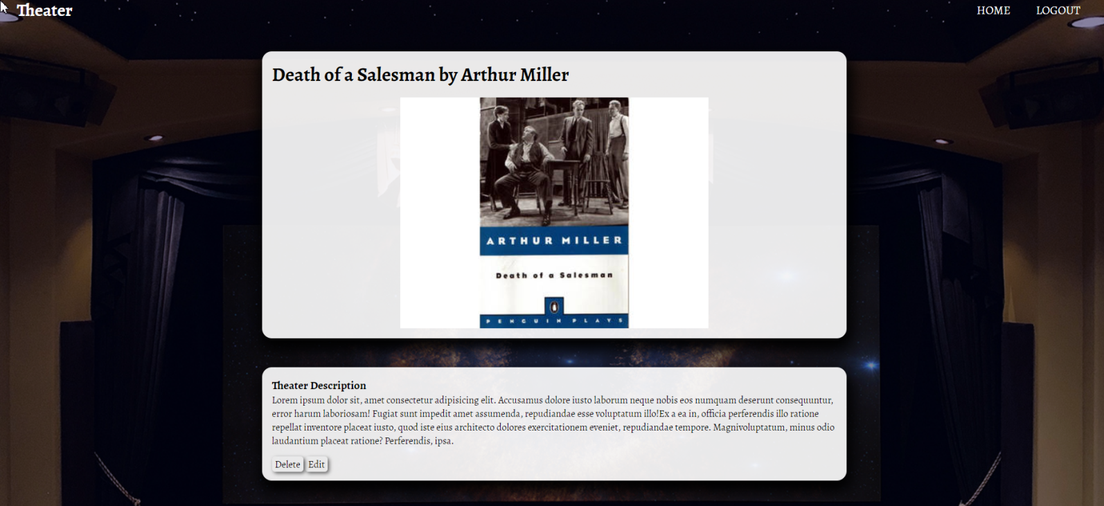

**Delete Play (Logged in User)**

Upon deleting a play (clicking over **[Delete] button**, you should be **redirected to the home page**.

**Edit Play (Logged in User)**

All form fields should be **filled automatically** with the corresponding information of the selected play.

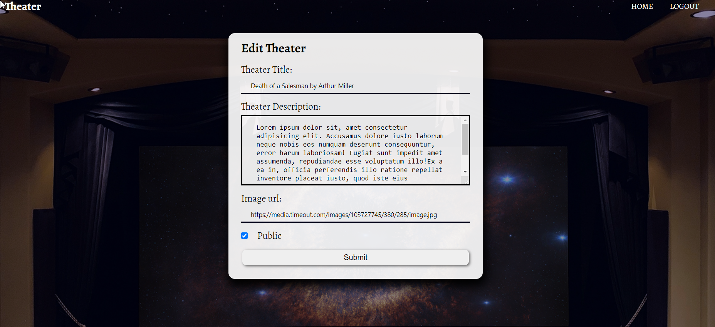

**Security Requirements (10 Pts)**

The Security Requirements are mainly **access** requirements. Configurations about which users can access specific functionalities and pages.

* Guest (not logged in) users can access Home page and functionality.
* Guest (not logged in) users can access Login page and functionality.
* Guest (not logged in) users can access Register page and functionality.
* Users (logged in) can access Home page (Listed all Plays)page and functionality.
* Users (logged in) can access **Play** Details page and functionality.
  + **Users** (not play creator) can **Like** a play **once**
  + **Users** (play creator) can **Edit** and **Delete** the current play
* Users (logged in) can access **Create Play** page and functionality.
* Users (logged in) can access Logout functionality.

**Validation and Error Handling (10 Pts)**

The application should notify the users about result of their actions.

### Login / Register

You should make the following validations:

* The **username** should be **at least 3 characters** long and should consist only **english** **letters** and **digits**
* The **password** should be **at least 3 characters** long and should consist only **english** **letters** and **digits**
* The **repeat password** should be **equal to the password**

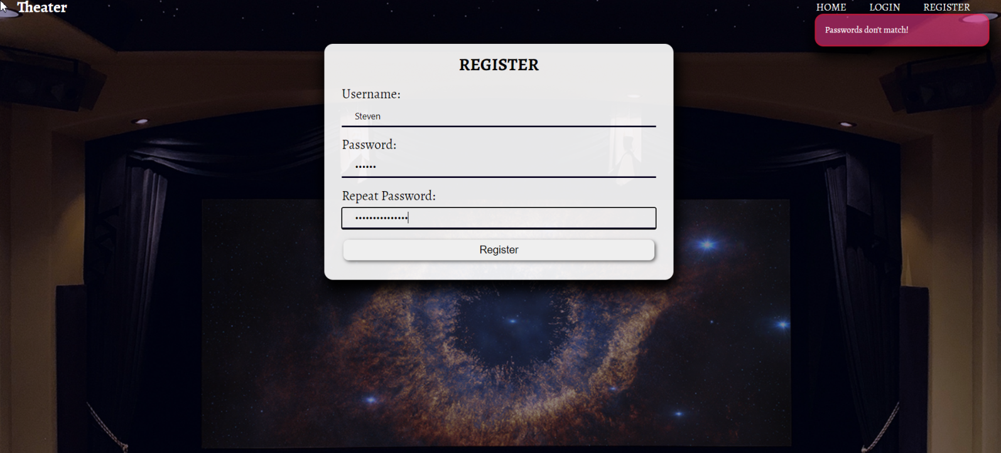

### Play

You should make the following validations while **creating** or **editing a** **play**:

* The **title** should **not be empty**
* The **description** should **not be empty**
* 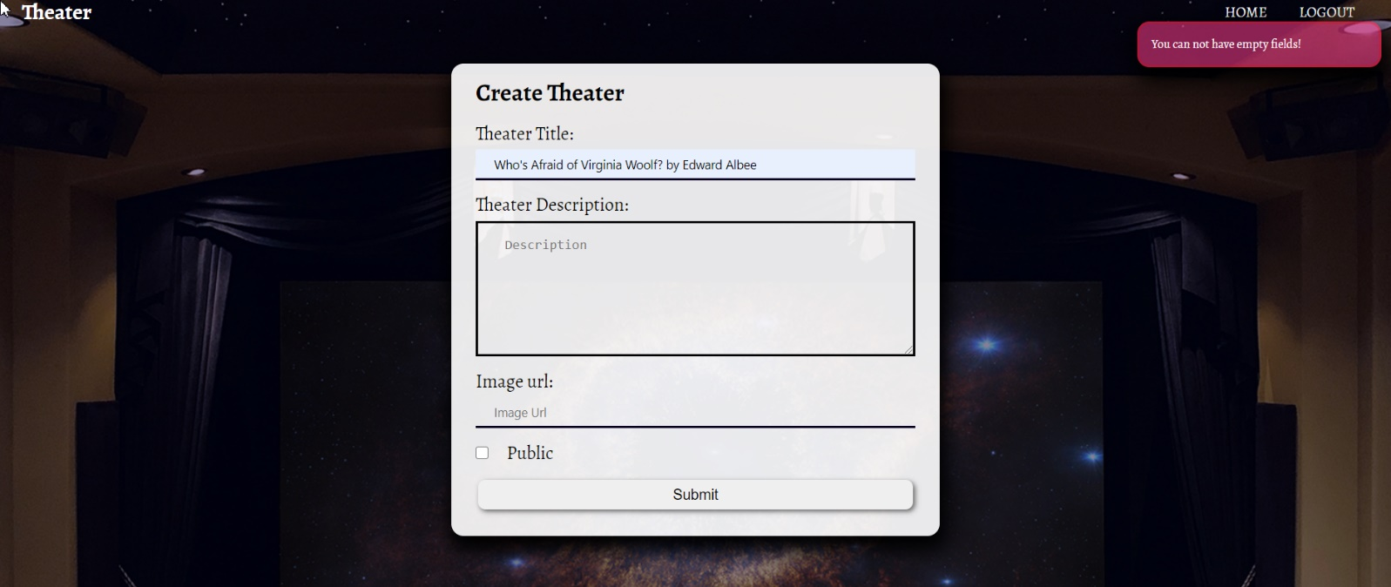The **imageUrl** should **not be empty**

**\* Bonus (10 Pts)**

**[Sort by Likes] -**  Filter only the **play with the most likes.**

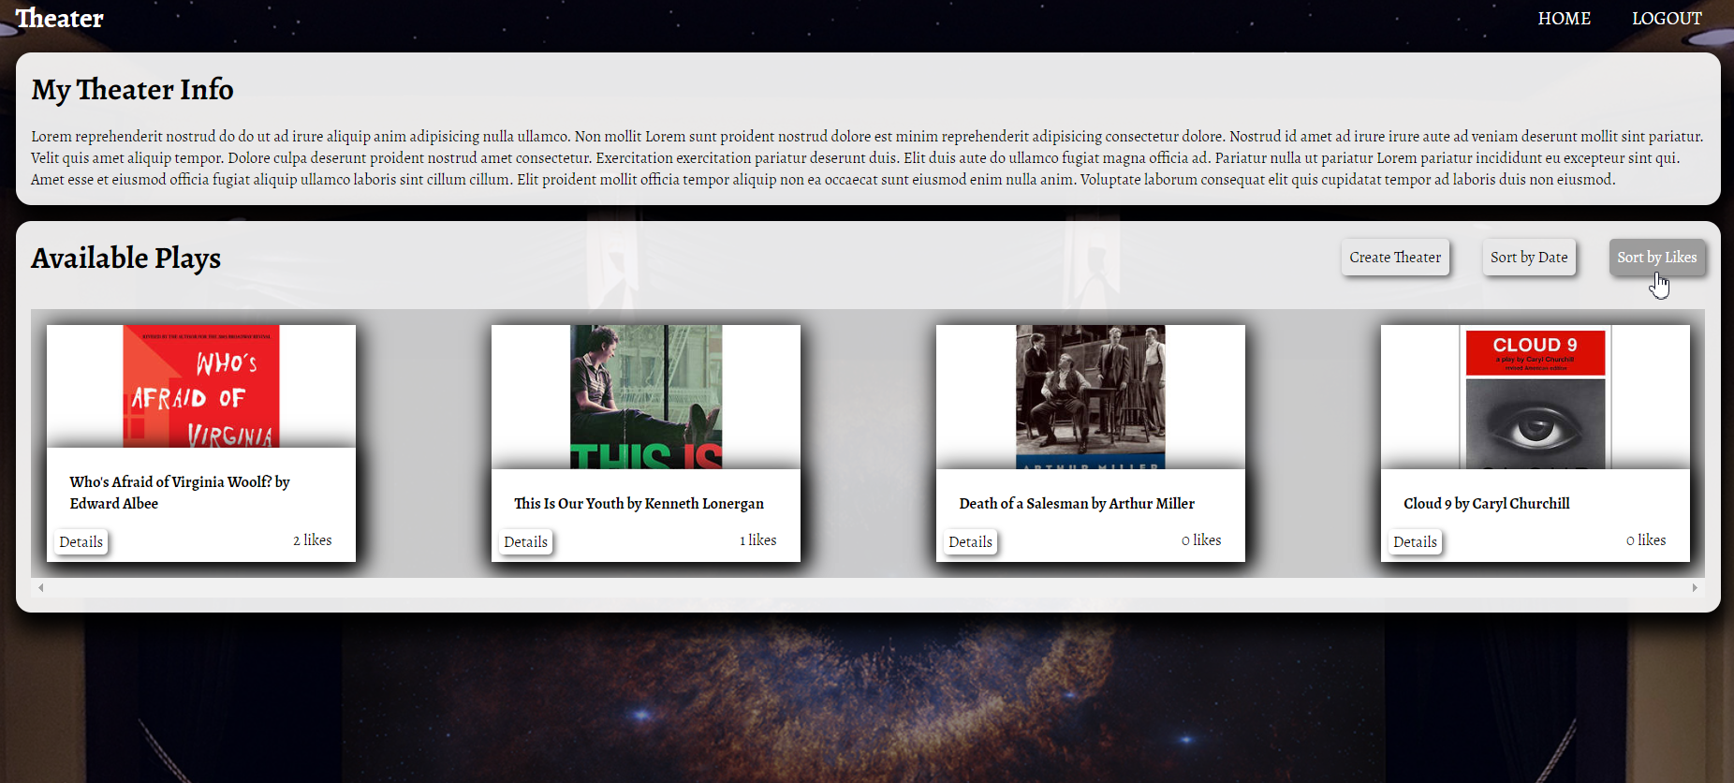

**[Sort by Date]** - Sort all plays by date from newest to oldest

